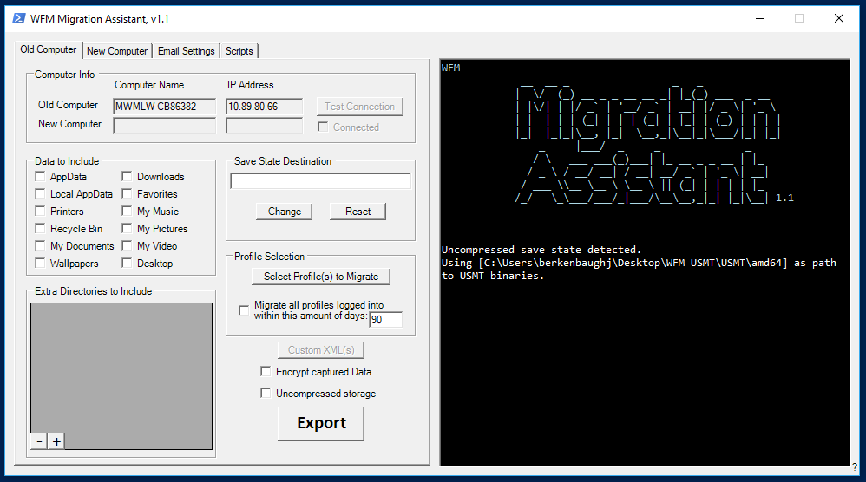

**Feature Disabled, so as not to confuse**

## Disabled features

Reason; Not valid options or unnecessarily confusing…

1. New Computer references from the Export (Migration) tab,
2. The Test Computer button on the Old Computer tab,
   1. The purpose is to manually test connection to the Old and New Computer.
3. The button for Custom XMLs is now inactive



